Julio Payao

08/27/2019

Assignment : Final Assignment

Assignment03

Final Assignment

Introduction: In this Assignment will go to try to create a Student registration

Topic 1: Home screen : In this screen you can login and login Request for

The new student.

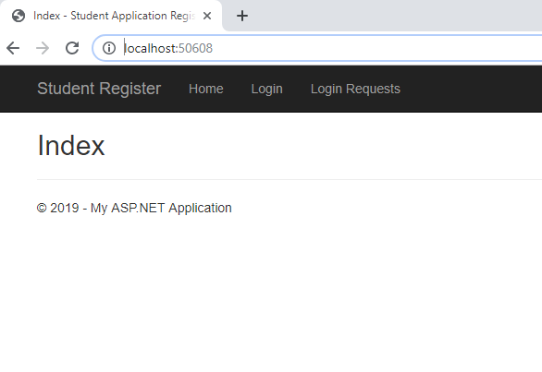

Topic 2: if you select the login request , now you can open a request.

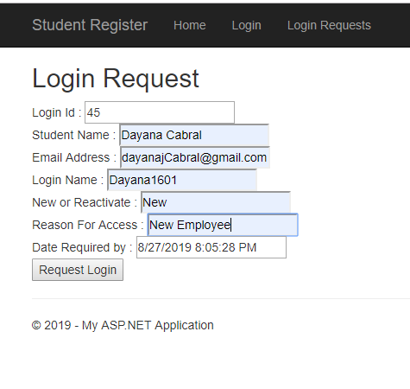

Figure 3 : Login pages , I create this screen using a Template for 3wschool

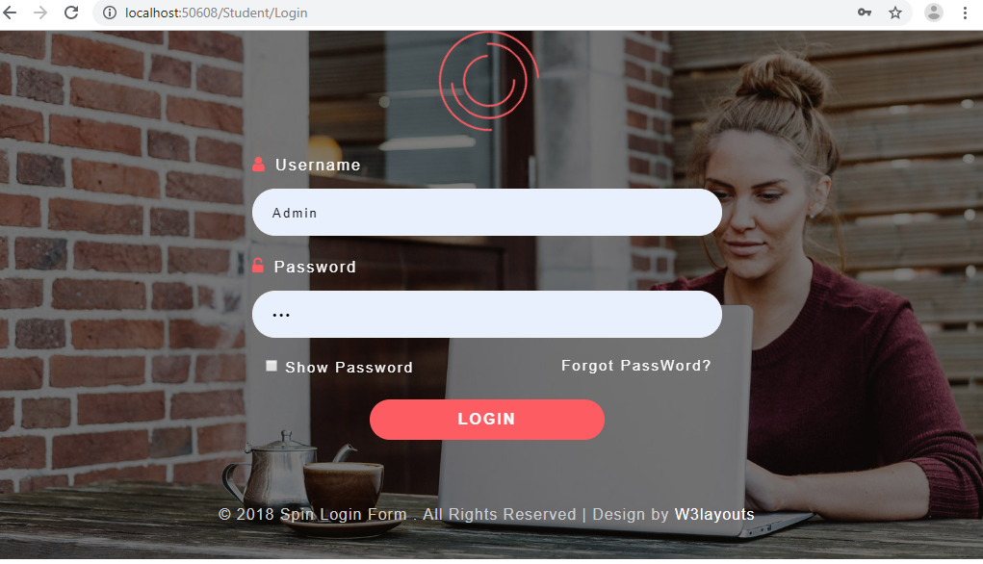

Figure 4: this is the main screen from here you can ,add ,edit and delete classes

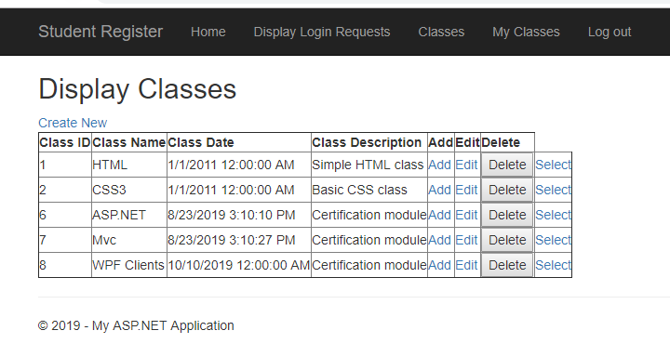

Figure 4: Testing Option ADD

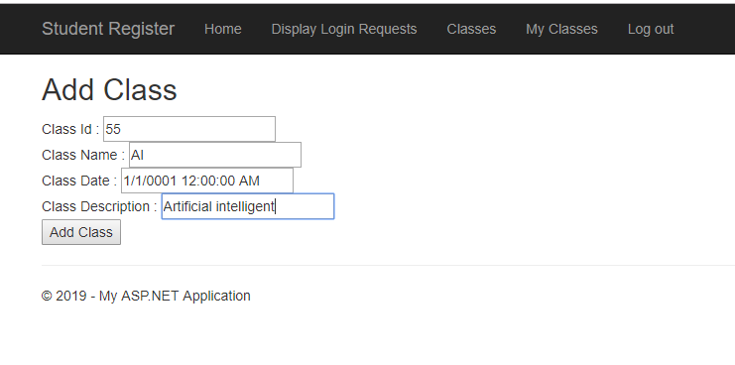

Figure 5 Option Edit

0

Summary: In this Module 03 I learn how to create a Master pages and create a content pages that can be used for display different information using a Master page. And how to call other pages form the master pages.

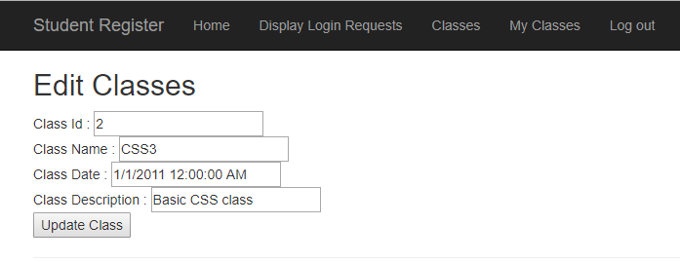

Figure 6 option Delete on this case if Cancel is click , nothing happen

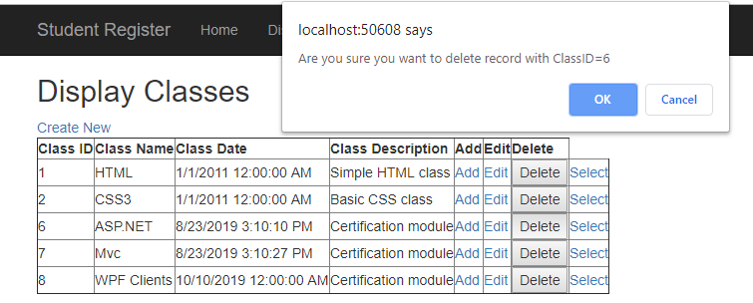

Figure 7 Display Login Request

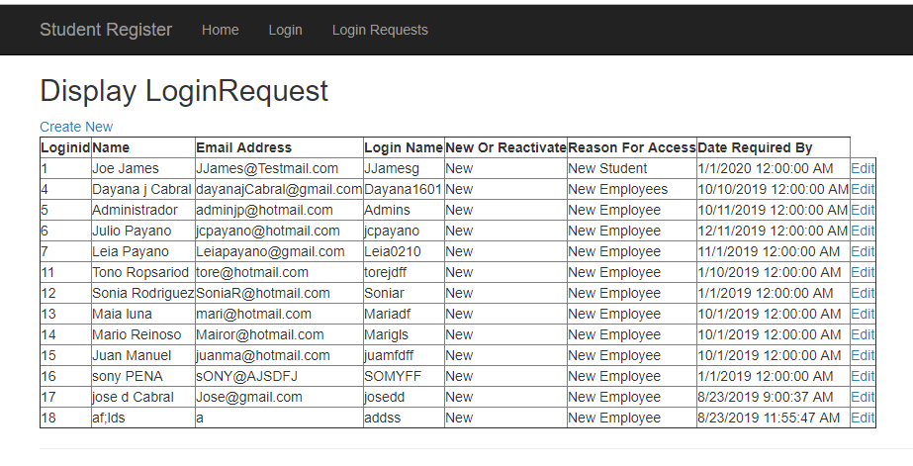

Summary: In this Classes I learn a lot, the classes was hard , I coming for a mainframe ,and the time don’t help me because I am in he EastCost ( Boston) . but this class help me, the most important was the way to tray to do everything the right way. From the Web page, Master pages, Controller , using layer , how to connect to deferent database , server, MVC , Razor, helper , store procedure for me the was a create step.

I Just want to tell you

Thank you Randal Root .